Sentiment Analysis Result

1. **Classification**

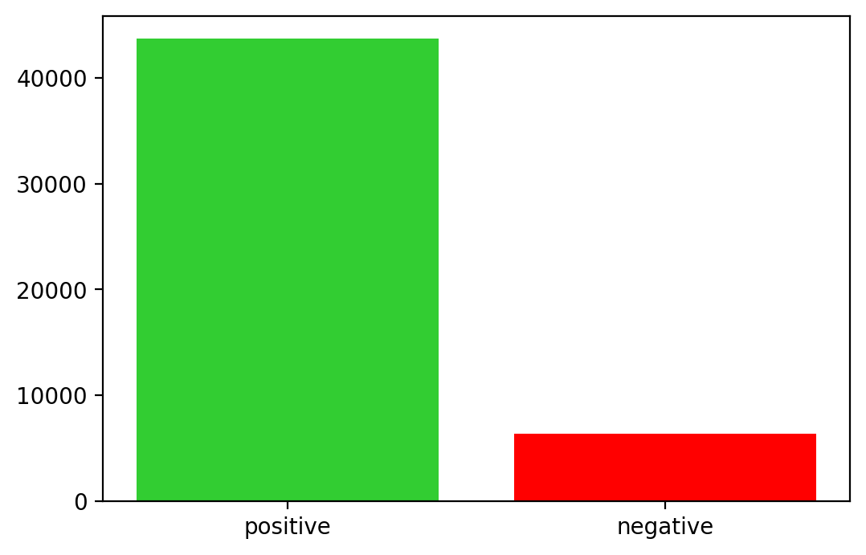

* The number of positive responses: 43686 (87.37%)
* The number of negative responses: 6314 (12.63%)

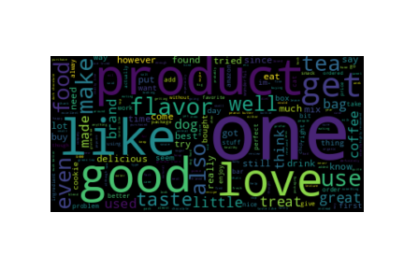

1. **Positive**

* The number of positive response: 43686
* Top 20 frequent words:

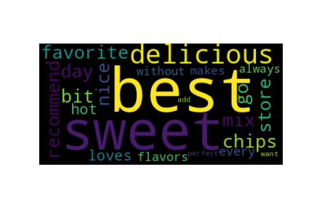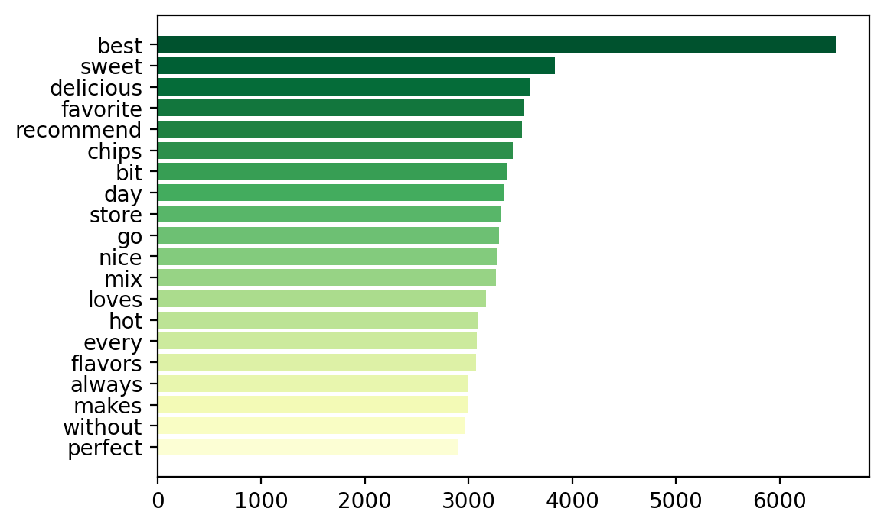

|  |  |
| --- | --- |
| word | count |
| best | 6537 |
| sweet | 3831 |
| delicious | 3591 |
| favorite | 3536 |
| recommend | 3516 |
| chips | 3428 |
| bit | 3367 |
| day | 3342 |
| store | 3316 |
| go | 3293 |
| nice | 3274 |
| mix | 3265 |
| loves | 3165 |
| hot | 3092 |
| every | 3078 |
| flavors | 3073 |
| always | 2993 |
| makes | 2988 |
| without | 2970 |
| perfect | 2902 |

1. **Negative**

* The number of negative response: 6314
* Top 20 frequent words:

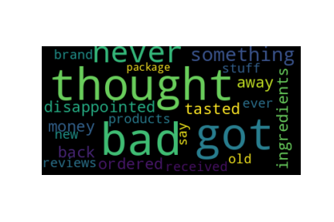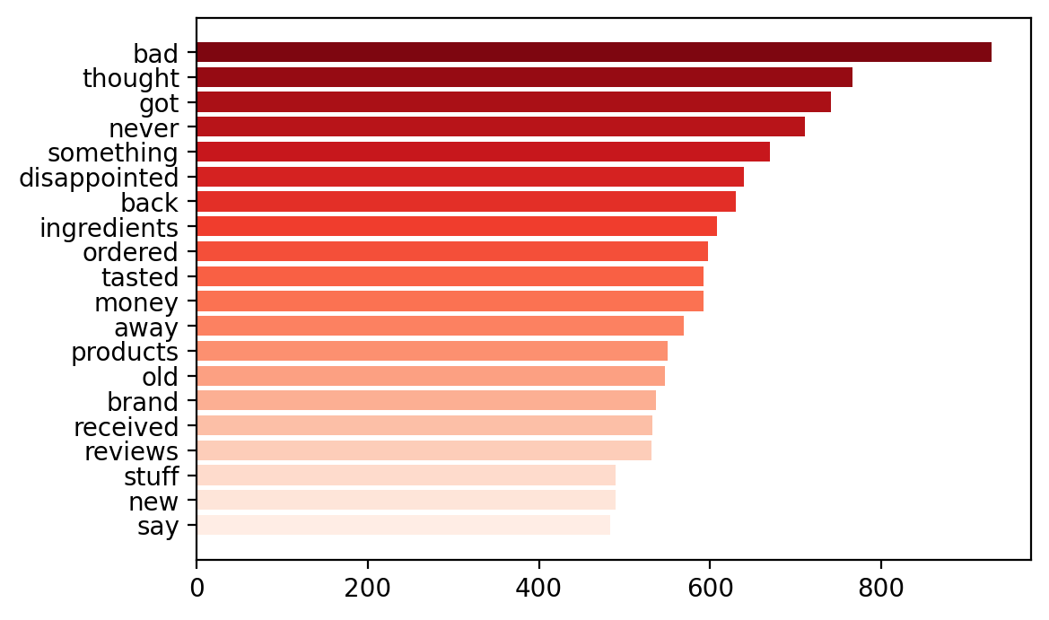

|  |  |
| --- | --- |
| word | count |
| bad | 929 |
| thought | 766 |
| got | 741 |
| never | 711 |
| something | 670 |
| disappointed | 639 |
| back | 630 |
| ingredients | 608 |
| ordered | 598 |
| tasted | 592 |
| money | 592 |
| away | 569 |
| products | 550 |
| old | 547 |
| brand | 537 |
| received | 532 |
| reviews | 531 |
| stuff | 490 |
| new | 489 |
| say | 483 |